**Nanopore flowcells**

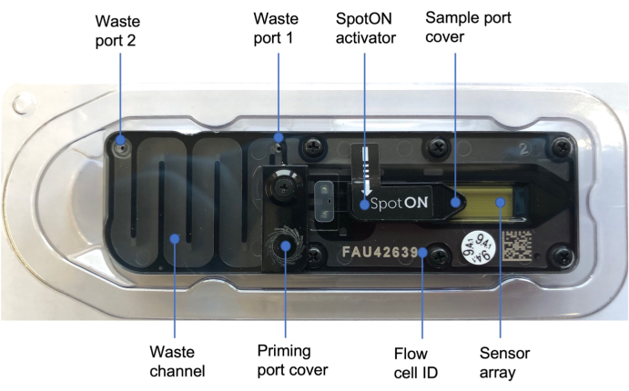

All Oxford Nanopore sequencing devices rely on flow cells for sequencing to take place. The flow cell is where the DNA/RNA library is loaded and sequenced. Different sequencing devices (e.g. minion, promethion, flongle) can only use compatible flow cells but they all containa core sensing unit — a nanopore set in an arrayed sensor chip — used alongside a bespoke Application-Specific Integrated Circuit (ASIC), which controls and measures the experiments. More detail on components:

|  |  |
| --- | --- |
|  | *Nanopores*  A protein nanopore is set in an electrically-resistant polymer membrane. |
|  | *Array of microscaffolds*  Each microscaffold supports a membrane and embedded nanopore. The array keeps the multiple nanopores stable during shipping and usage. |
| An array chip | *Sensor chip*  Each microscaffold corresponds to its own electrode that is connected. An array chip to a channel in the sensor array chip. Sensor arrays may be manufactured with any number of channels. |
| ASIC | *ASIC*  Each nanopore channel is controlled ASIC and measured individually by the bespoke ASIC. This allows for multiple nanopore experiments to be performed in parallel. More than one ASIC may be included in a device and Oxford Nanopore is building ASICs of different sizes for different purposes. |

*Table. Flowcell details*

| **Flow cell** | **Flongle** | **MinION/GridION** | **PromethION** |
| --- | --- | --- | --- |
| Device | MinION Mk1B, Mk1C and GridION | MinION Mk1B, Mk1C and GridION | PromethION |
| Storage and stability (unopened) | 2-8°C: 4 weeks | Room temp: 1 month 2-8°C: 12 weeks | Room temp: 1 month 2-8°C: long term |
| Pore count warranty | ≥ 50 | ≥ 800 | ≥ 5000 |

**Very important points:**

* NEVER freeze a flowcell! Freezing irreversibly destroys the pores. They must be stored in a fridge (2-8°C).
* Air bubbles are very bad for flowcells, again irreversibly destroying the pores. If the flowcell is received with an air bubble you have a right to request a replacement. If it gets one after the warranty period, it’s essentially unusable. The key is *prevention,* avoid introducing air bubbles into the flowcell by using good technique during flowcell priming.

**Flowcell info**

The flowcell contains a membrane which holds the nanopores used for sequencing. Theoretically, there are 2048 pores on a membrane but in reality not all of these are present or active. These pores are placed into groups of 4, with one channel per group. The channel can only read the electical signal disruption from 1 out of the 4 pores at any one time, therefore the flowcell chooses the “best” available pore out of the group to initiate sequencing with. It is during the flowcell check that the pores are assessed and chosen for sequencing. So at any one time there is a maximum of 512 pores sequencing (i.e. 2048 divided by 4).

**Receiving a flowcell**

Flowcells are wrapped individually in a protective plastic case and shipped to users. It’s important to activate the warranty by doing a flowcell quality check within 15-days of receiving. This will determine if the quality of the flowcell is acceptable or if you are entitled to a replacement. At this point also do a few quick physical checks: look for air bubbles on the sensor array, check for obvious damage (cracks in plastic etc), check the asic chip pins are straight and not bent out of shape and finally, check that the heat pad on the underside of the flowcell (black pad on asic) is in place.

**Flowcell cell check**

A flowcell check constitutes a pore scan to analyse pore status and select the best performing pores for sequencing. Flowcell checks should be performed to activate warranty, but also before every run (to ensure flowcell is still ok). During the process of setting up the run to sequencing a pore scan is also performed just before sequencing commences.

During the scan pores are classified into different statuses- ‘active’, ‘unavailable’, ‘saturated’ etc and the MinKNOW software show a visual of this with different colours for each status. Green is the colour for active pores, so basically you want to see a “sea of green” that indicates more of the pores are activate and can be used for sequencing. During sequencing, pores can be further characterised into 2 green states- active and sequencing. The ‘pore occupancy’ is the proportion of overall available pores (active+sequencing) that are sequencing. The higher this number, the better (basically). However, for very short reads (e.g. 400bp) the software struggles to give an accurate representation of the pore occupancy because reads go through the pore so quickly. Around 50-70% would be expected for a good run for short reads.

If there is a high level of ‘unavailable’ pores, washing the flow cell is recommended as there may be blocking occuring which will reduce sequencing and data output. The rate of blocking is mainly due to the purity of the sample; low quality DNA/RNA or contamination from either extraction, sample prep or secondary structure can be some of the causes of an increase of pores in the unavailable state.

**Using a flowcell**

Initially the flowcell contains a Storage Buffer (this is yellow), which protects membrane and pores until use. Before a run, this will be replaced with a mix to prepare the pores for sequencing. The flow cell holds sufficient buffer to run for up to or more than 72 hours (depending on the flow cell). Note, the “lifespan” of a flowcell is max 72 hours, under optimal conditions, but in reality this is not usually the case. Pores naturally degrade and die-off through time, some things can accelerate pore degradation e.g. library contaminants. A user can choose to run continuously or run, stop, wash and load a new library until the buffer and nanopores are exhausted. This enables a single flow cell to be used multiple times before the nanopores are exhausted. An individual flow cell may also be used for different experiments.

**Flowcell washing and reuse**

Flowcells can be washed using the Flowcell wash kit, which contains the nuclease DNase I. This digests the remaining library on the flowcell so it is ready for either immediate reuse or for storage for later reuse. The wash step is recommended when there is an accumulation of pores in the ‘recovering/unavailable’ states, as the wash can recover these pores (back to ‘active’) OR when you want to clean the flowcell to reuse with a different library.

The flow cell wash kit allows multiple uses of a flow cell with different samples and the recovery of unavailable channels during an experiment. Samples can be multiplexed to reduce costs and sequence many samples simultaneously on a single flow cell, for example using one of the Native Barcoding kits or the PCR Barcoding Expansion.

Note: The wash kit should remove 99% of the library. However, some residual DNA may remain on the flow cell. Best to use different sets of barcodes on consecutive runs to be sure.